CT303 LAB REPORT

Aarsh Bhavsar

Student ID:202101474a

Lab-6

OCTOBER 29, 2023

DAIICT

**Experiment -1**

**Problem 1:**

**CH 1: DATA CLK (266 KHz) & CH 2: SERIAL DATA (00011011)**

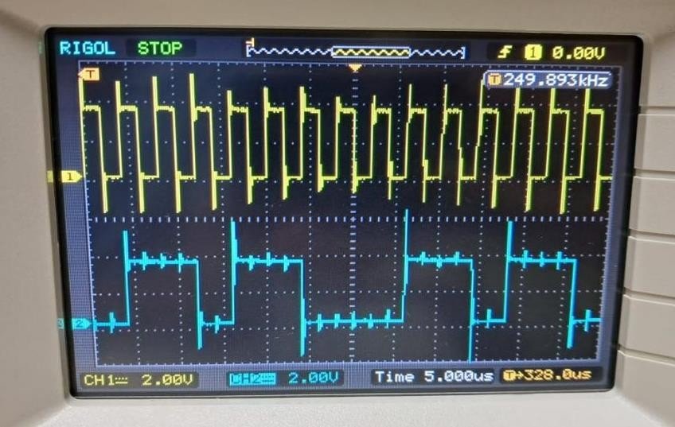

**CH 1:DATA IN& CH 2:NRZ-L**

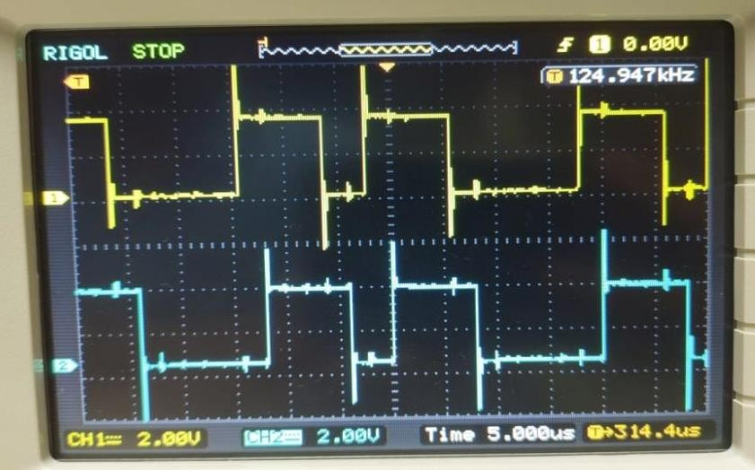

**CH 1: DATA IN& CH 2: NRZ-M**

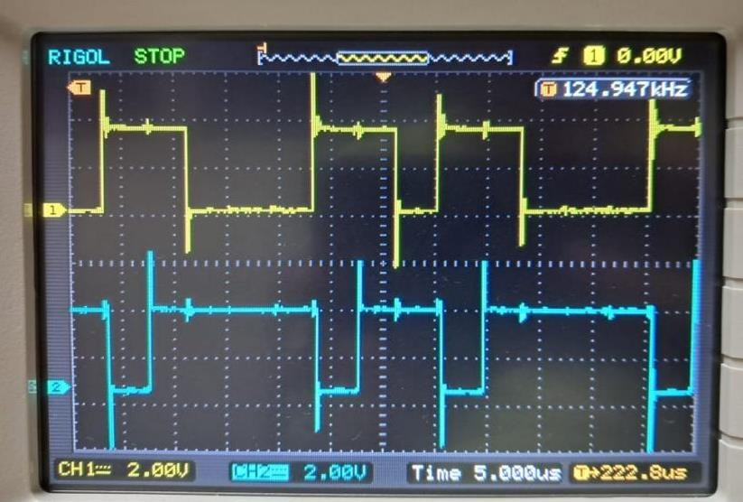

**CH 1: DATA IN& CH 2: NRZ-S**

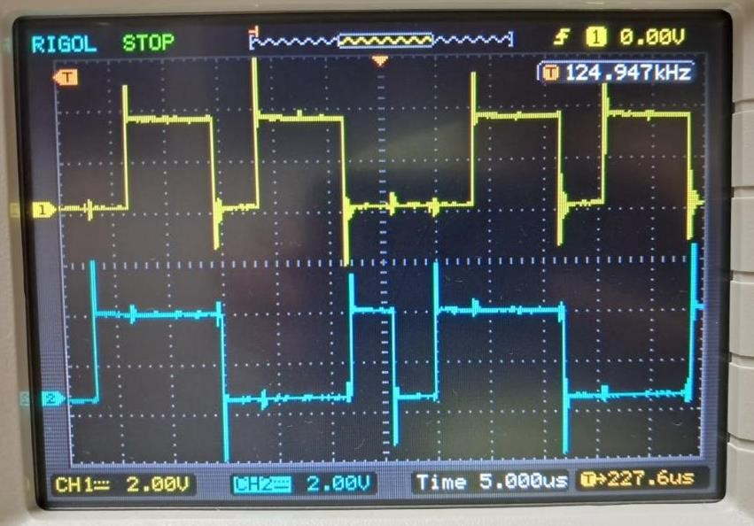

**CH 1:DATA IN& CH 2: OUT1**

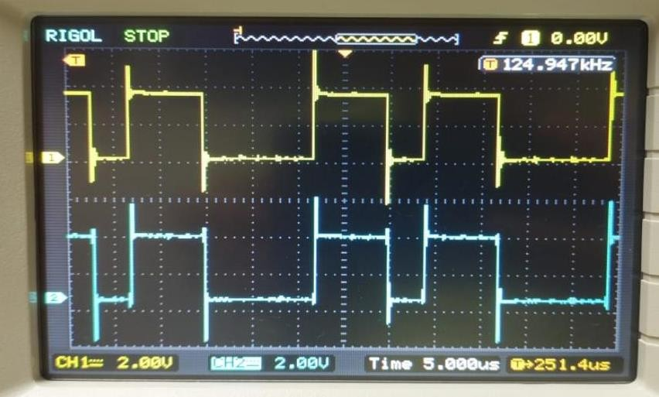

**CH 1: DATA IN& CH 2: OUT2**

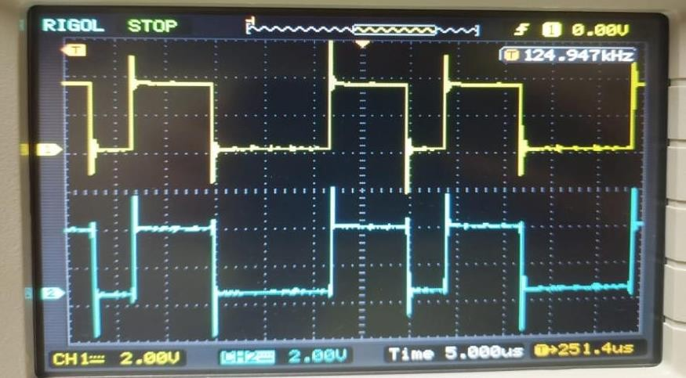

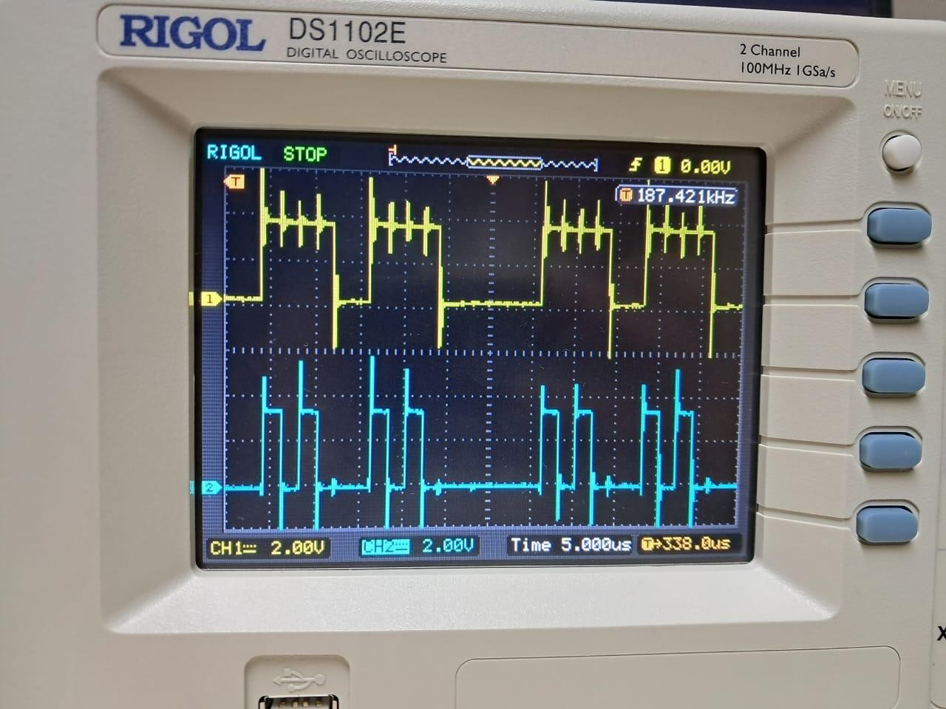

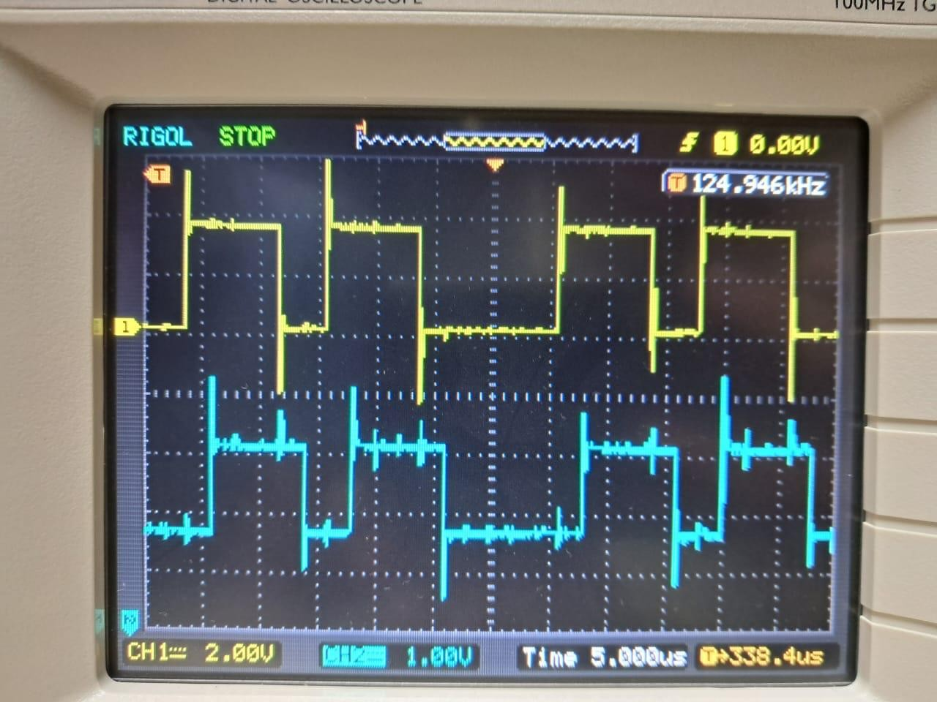



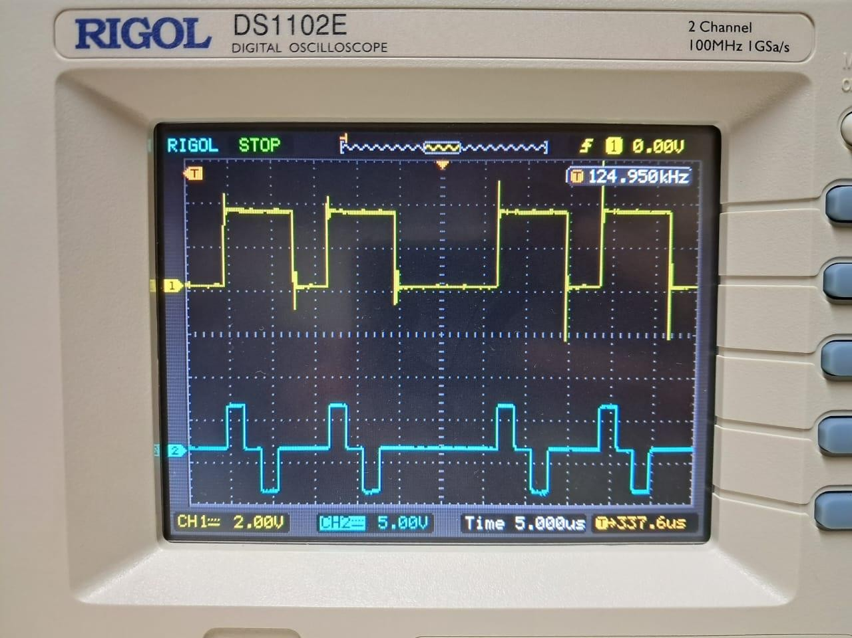

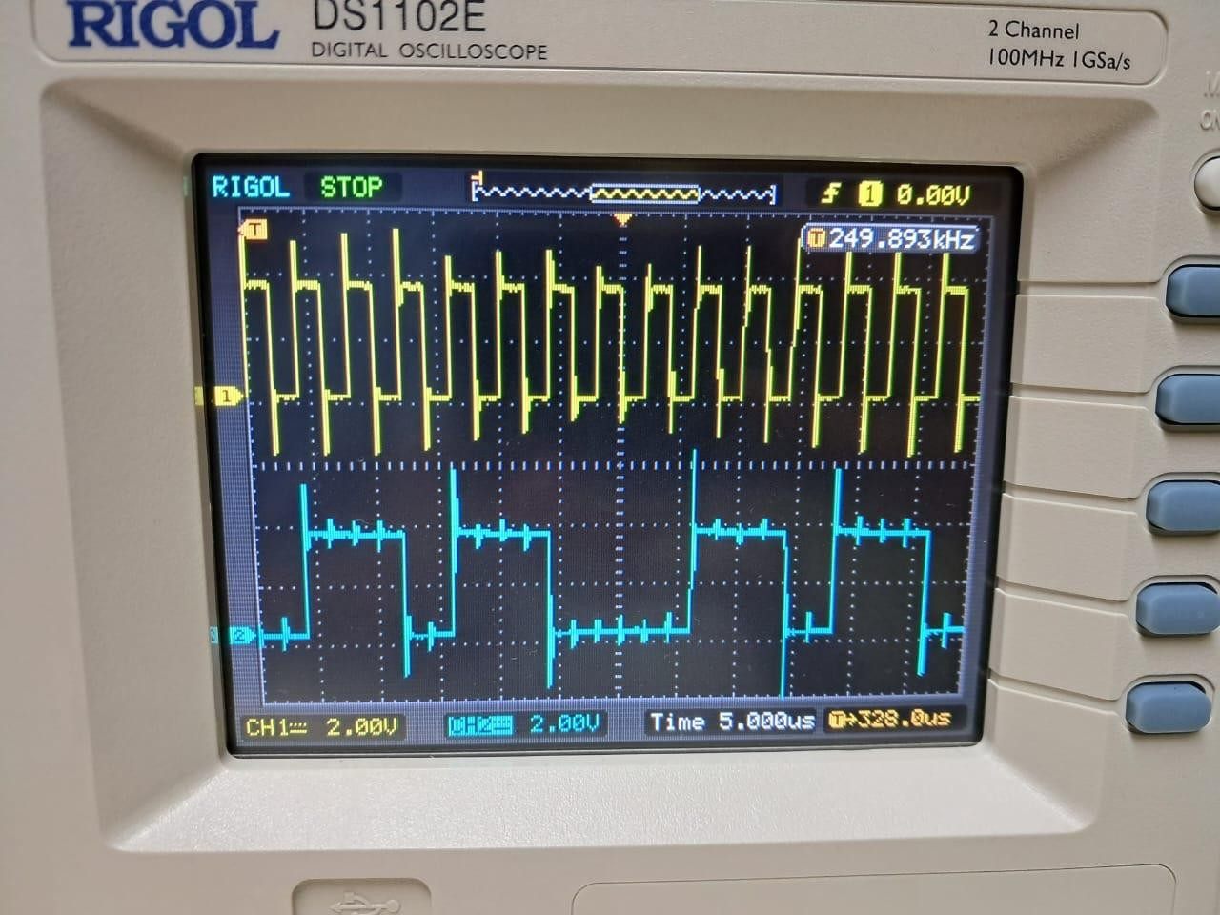

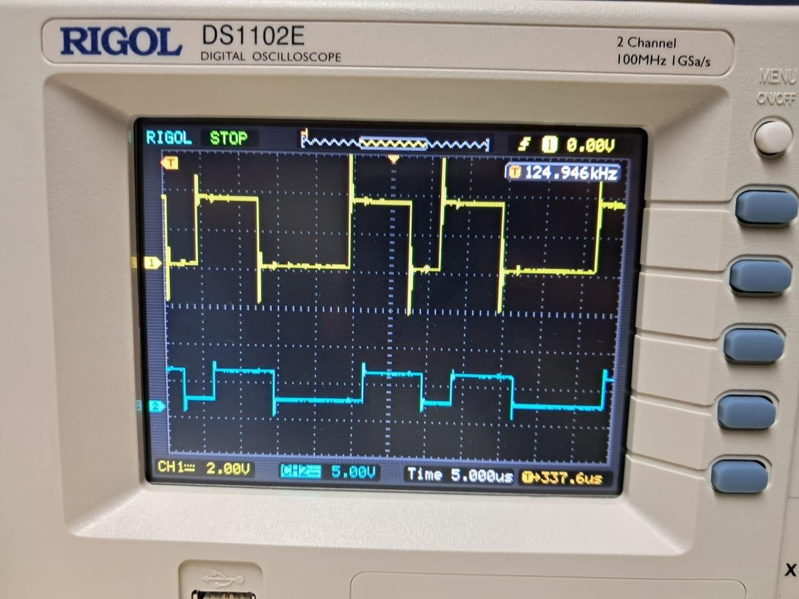

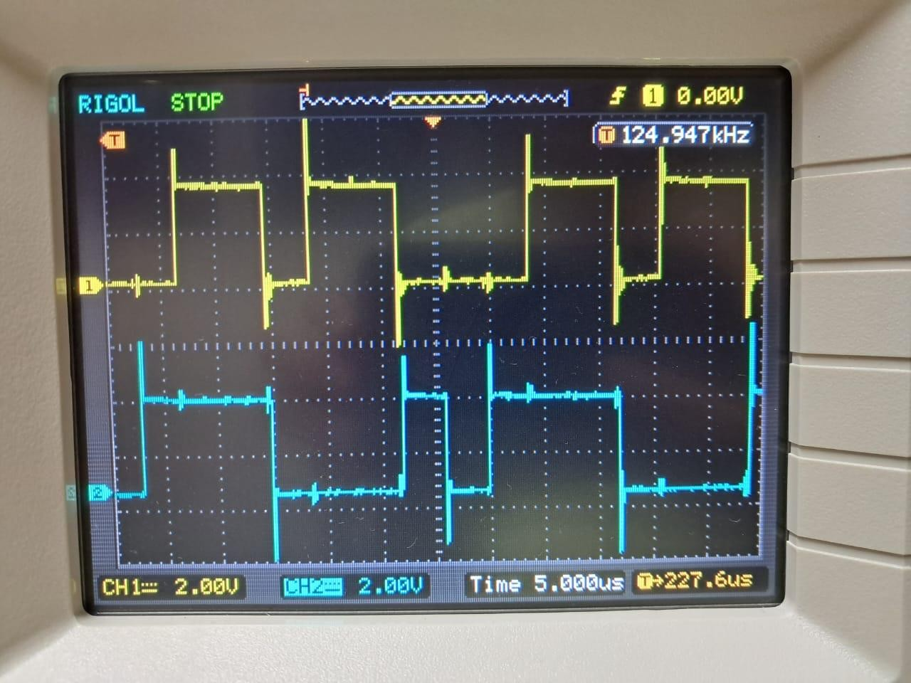

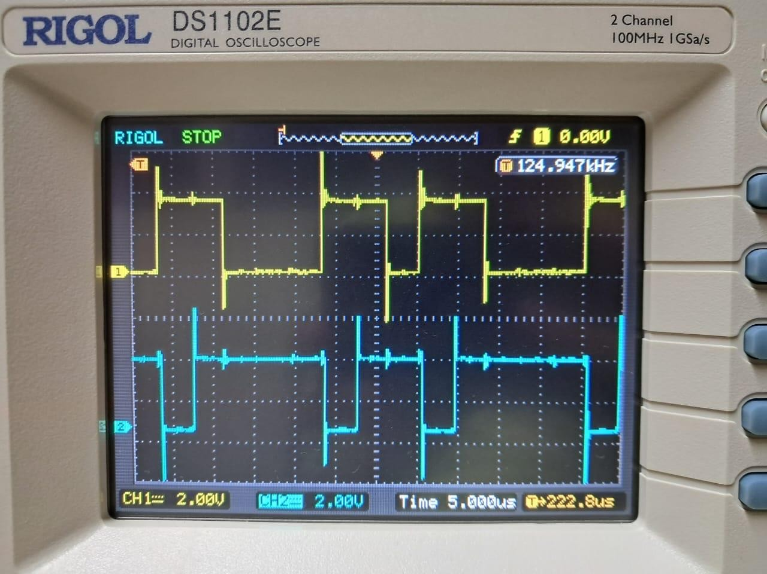

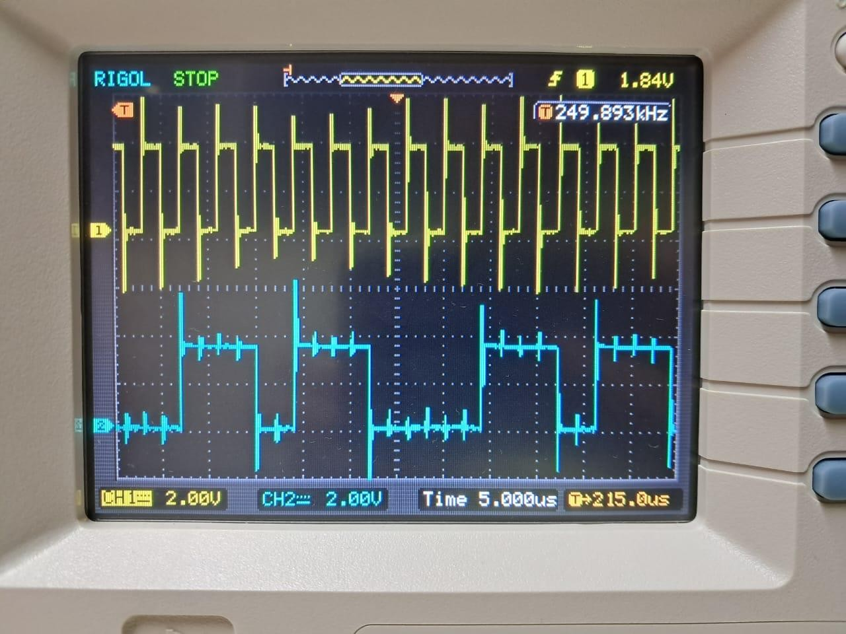

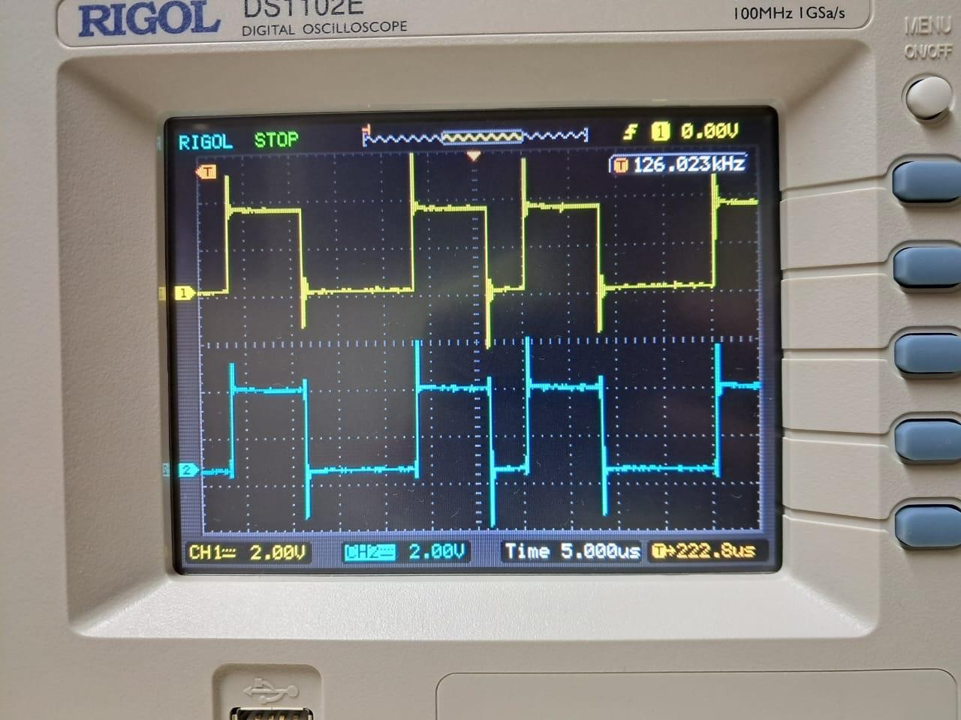

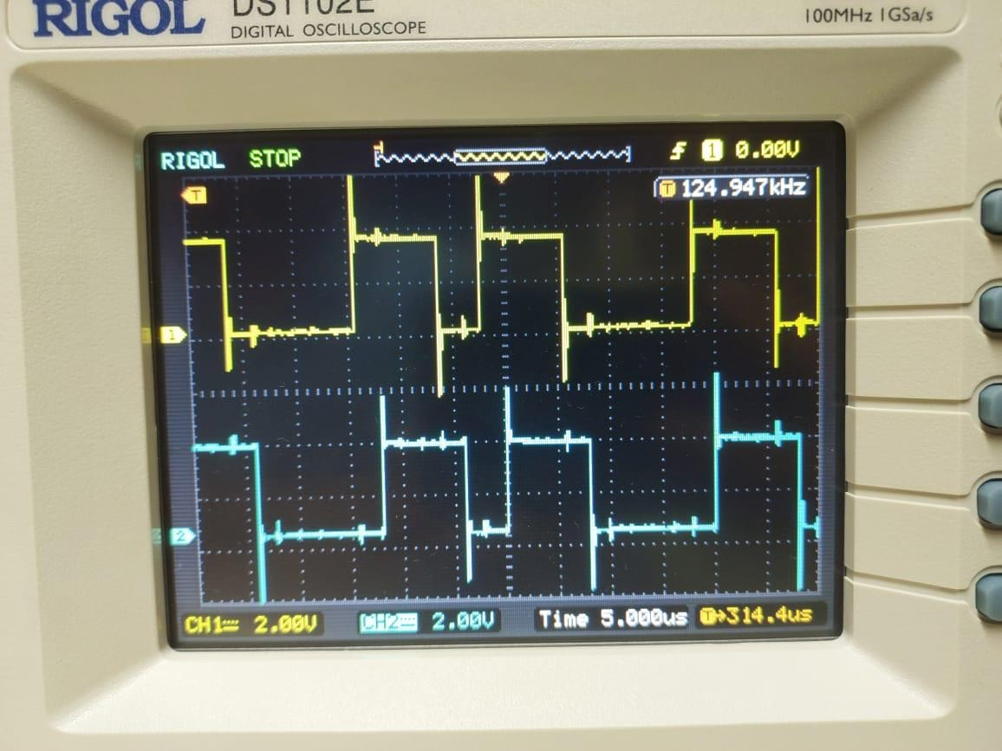

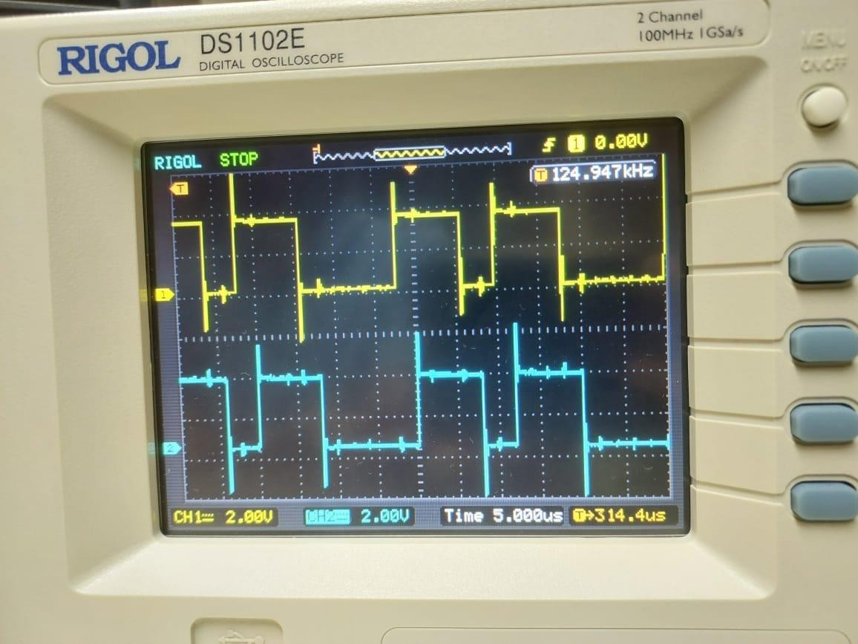

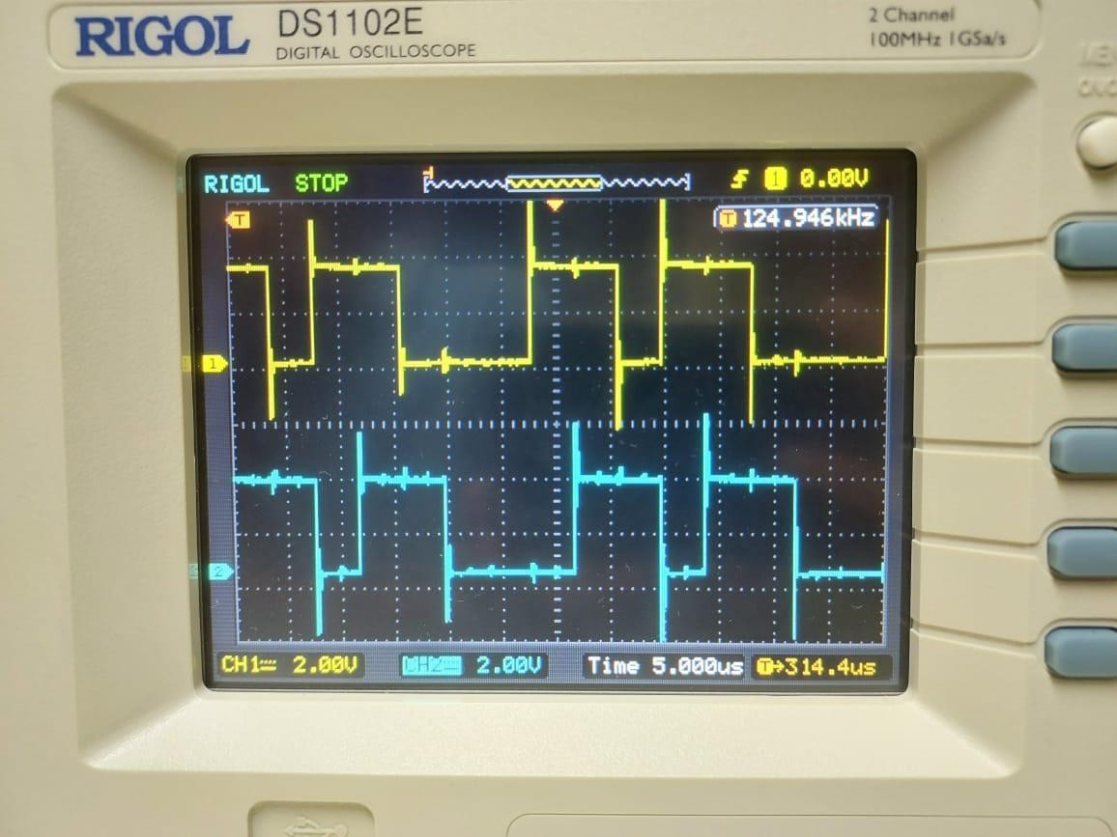

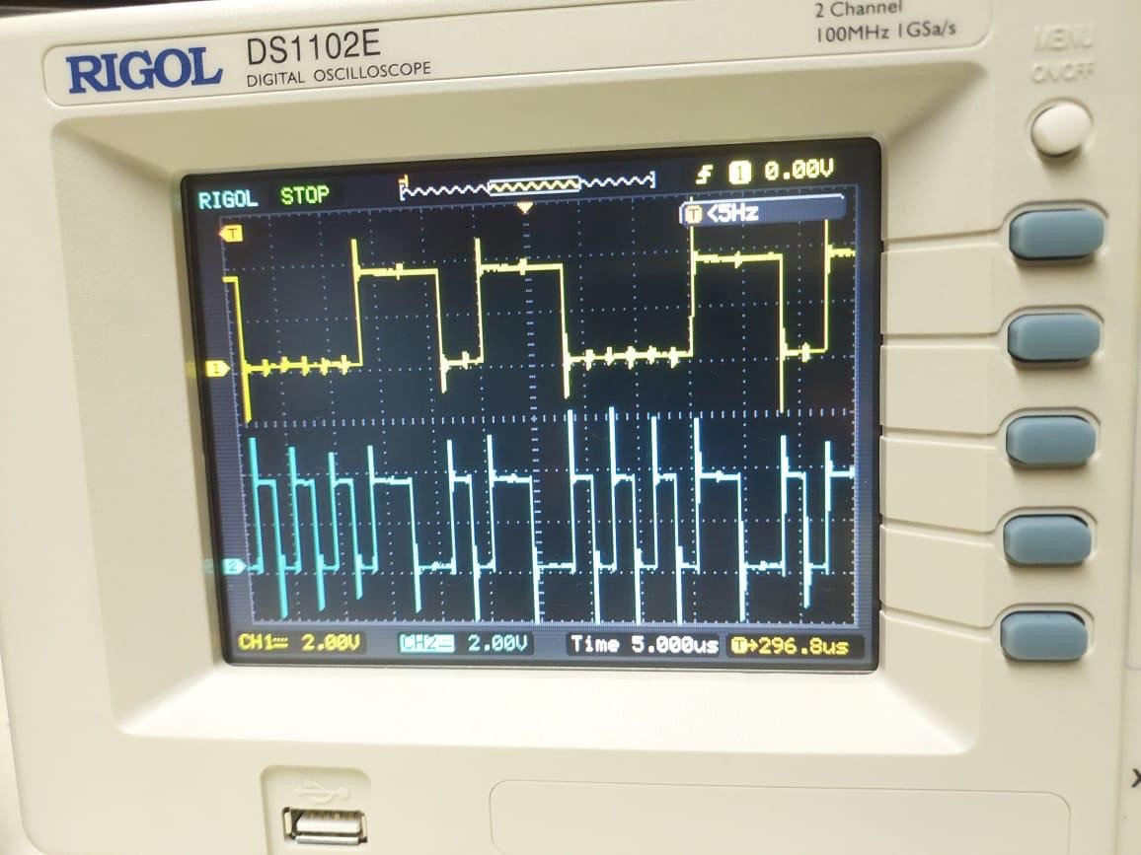

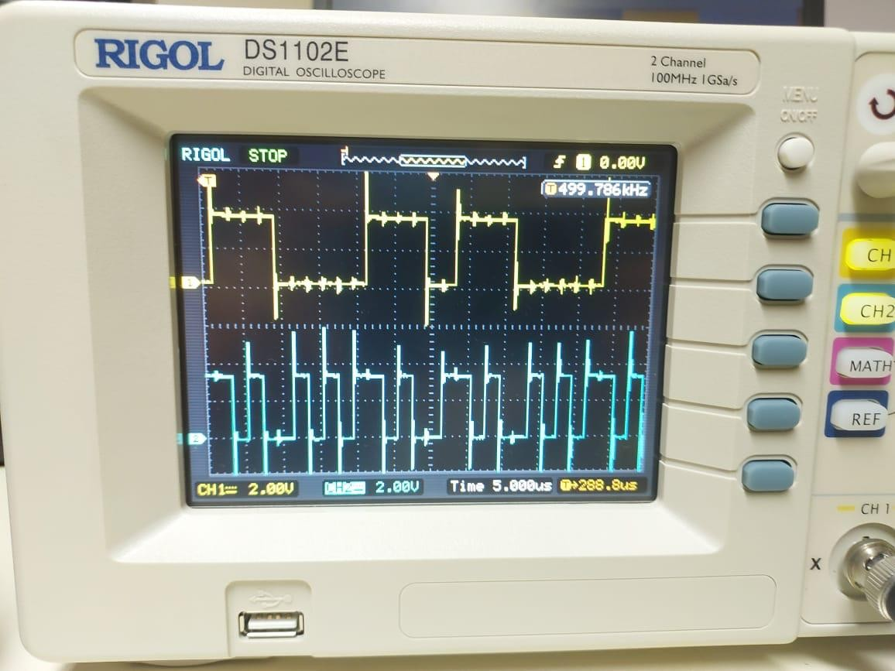

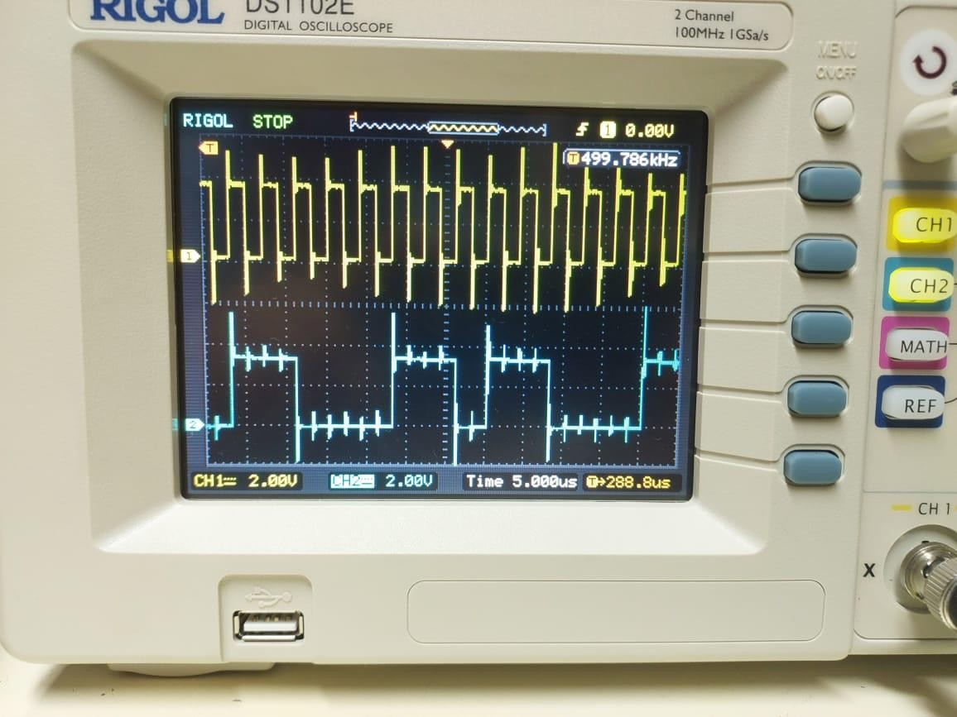

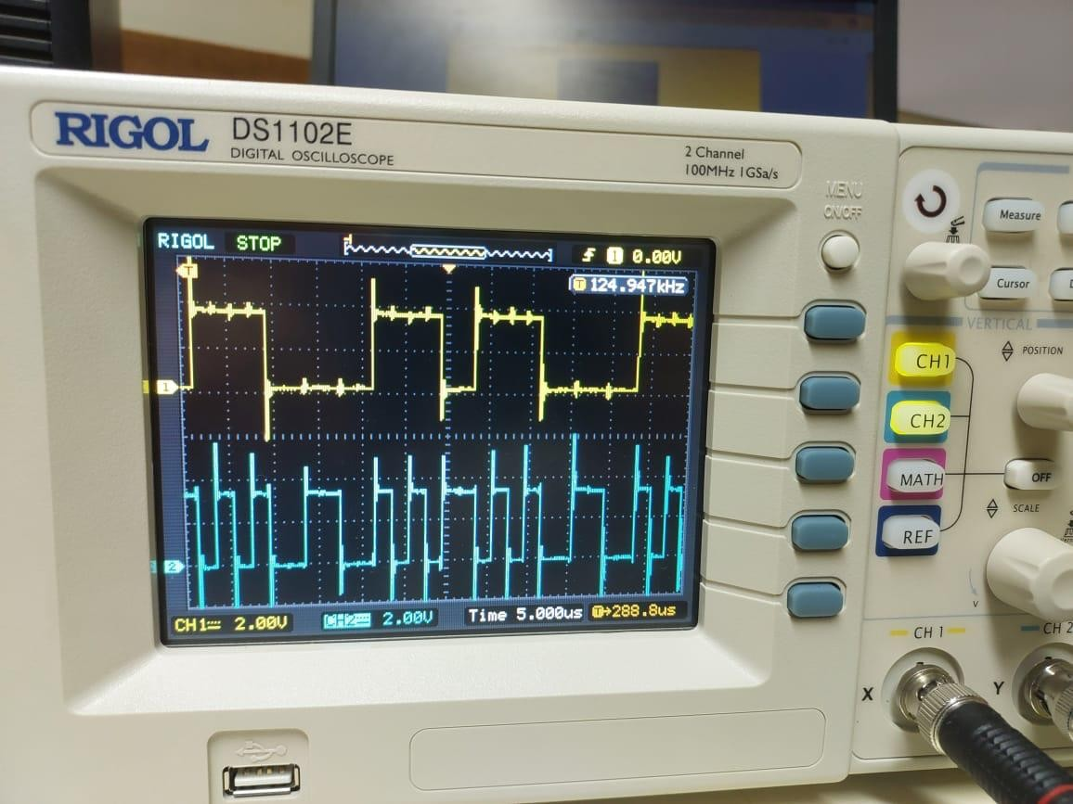

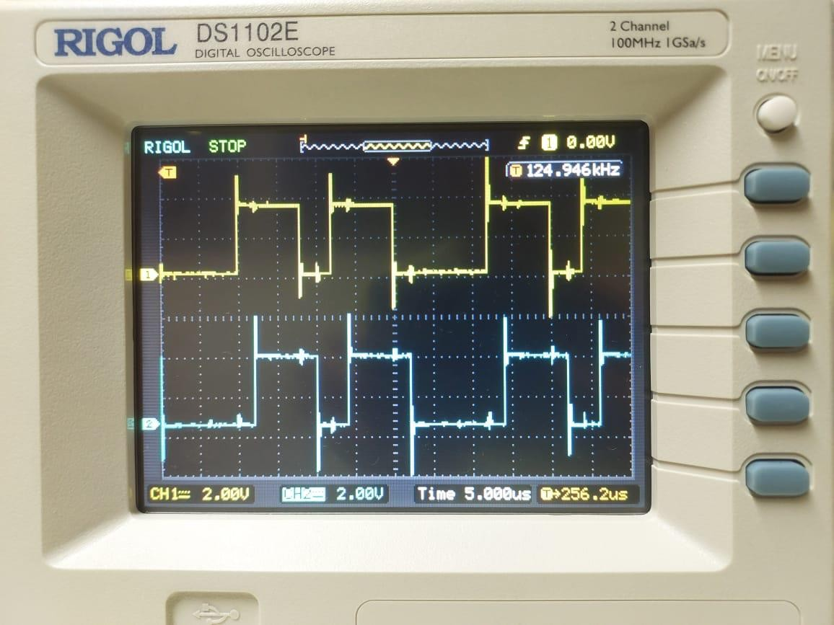

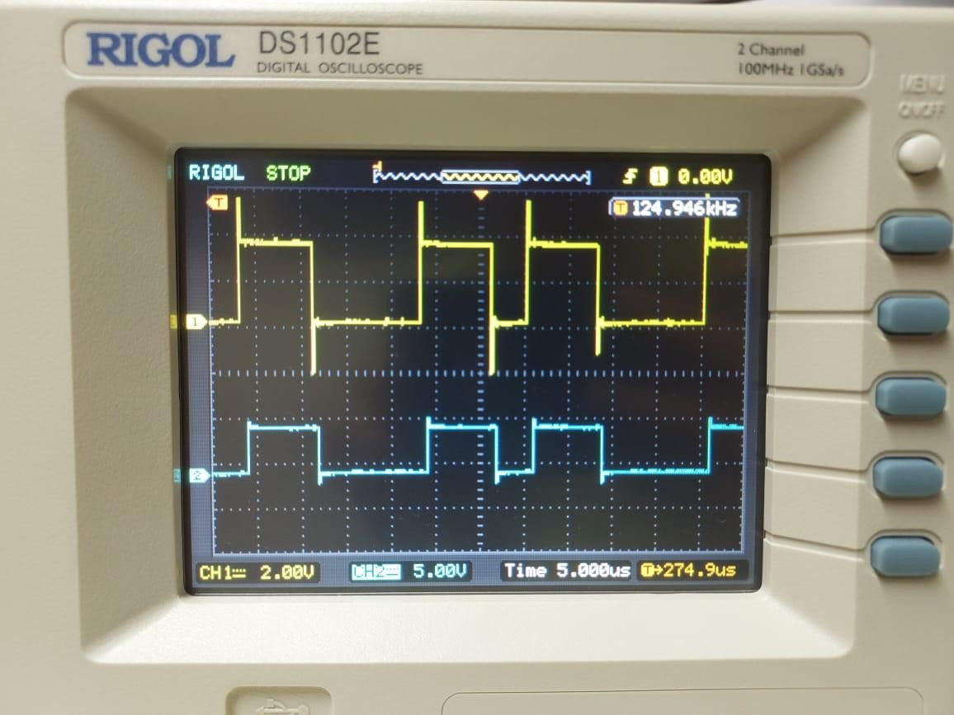

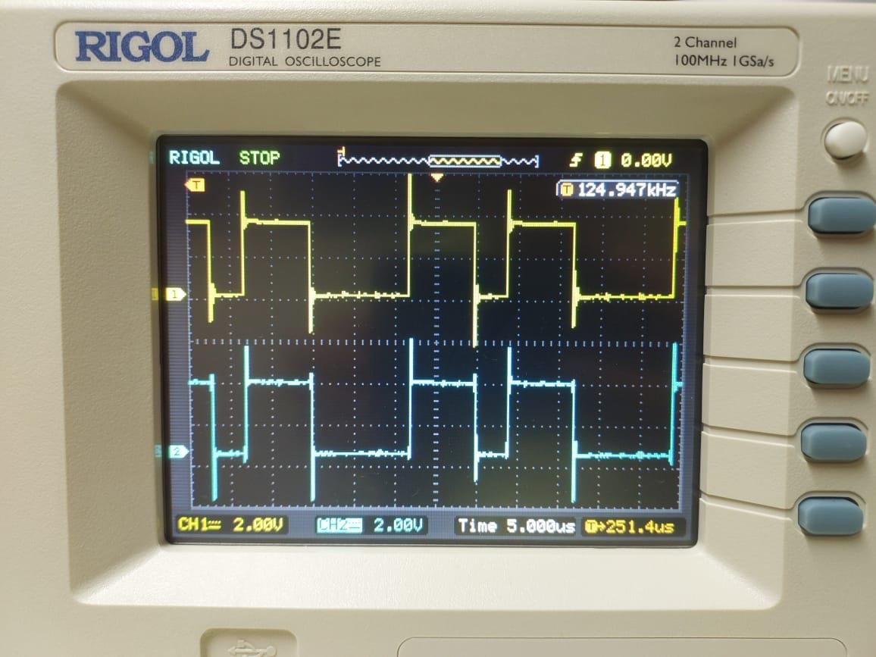

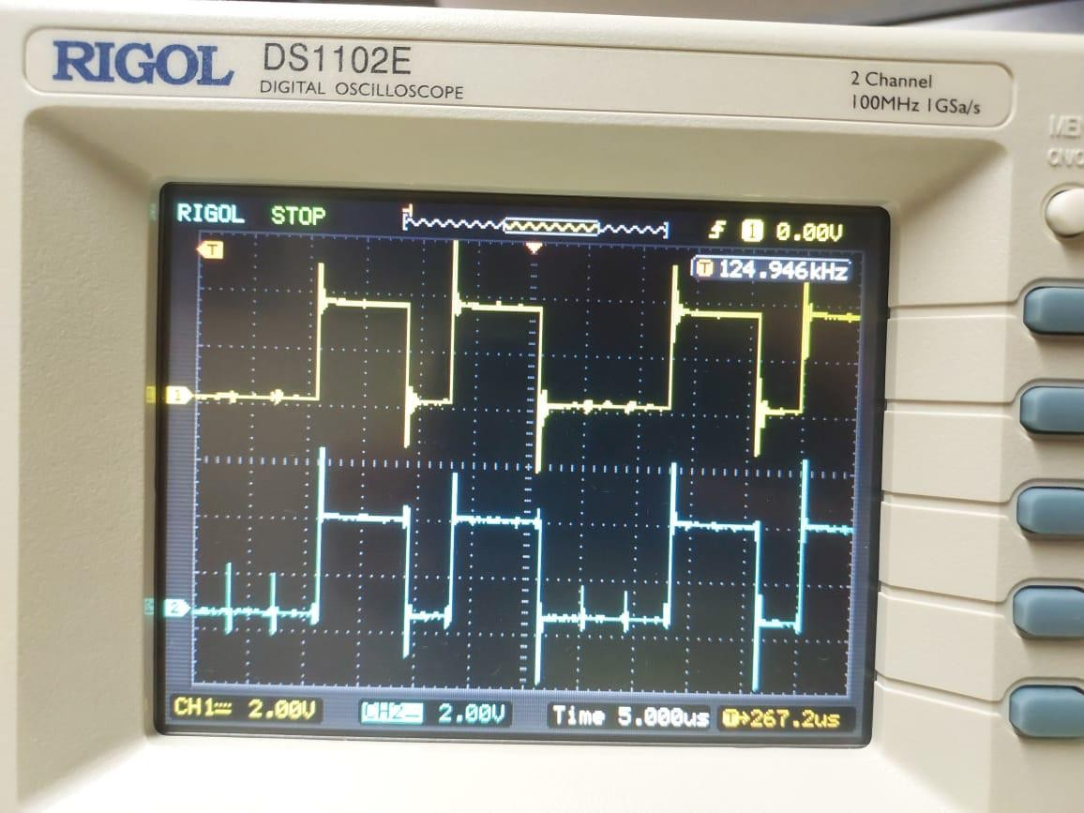

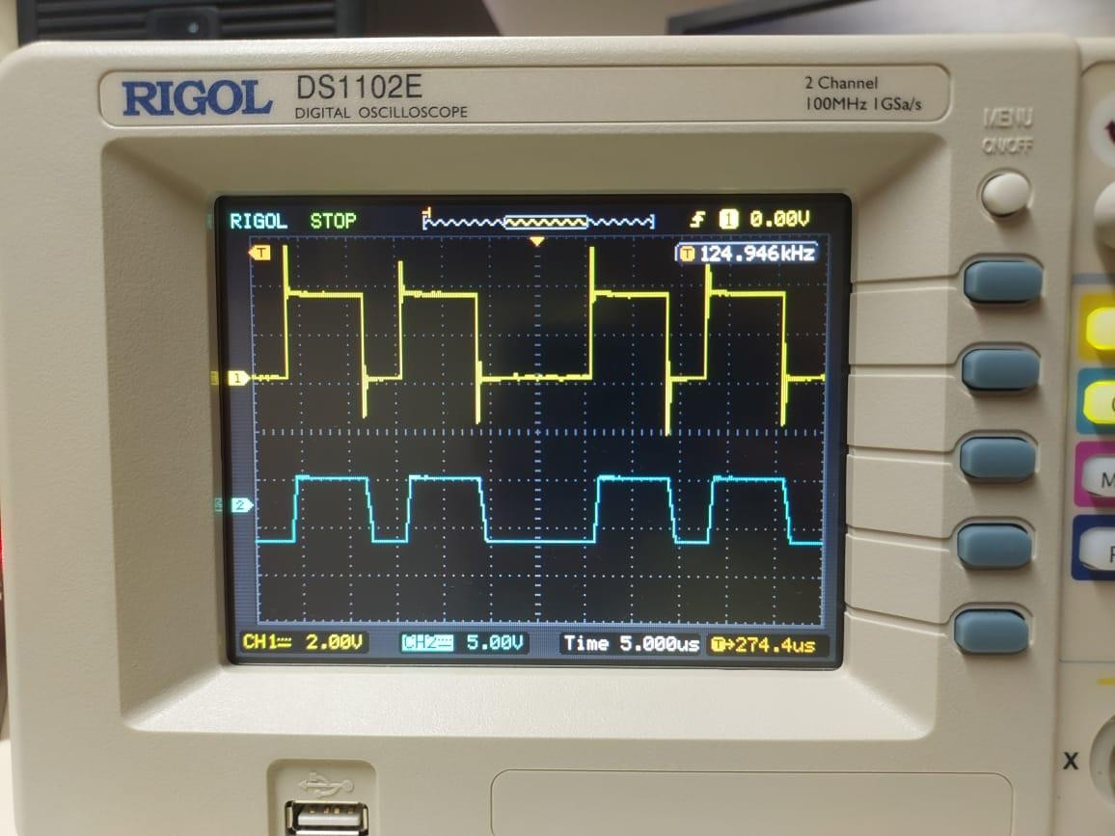

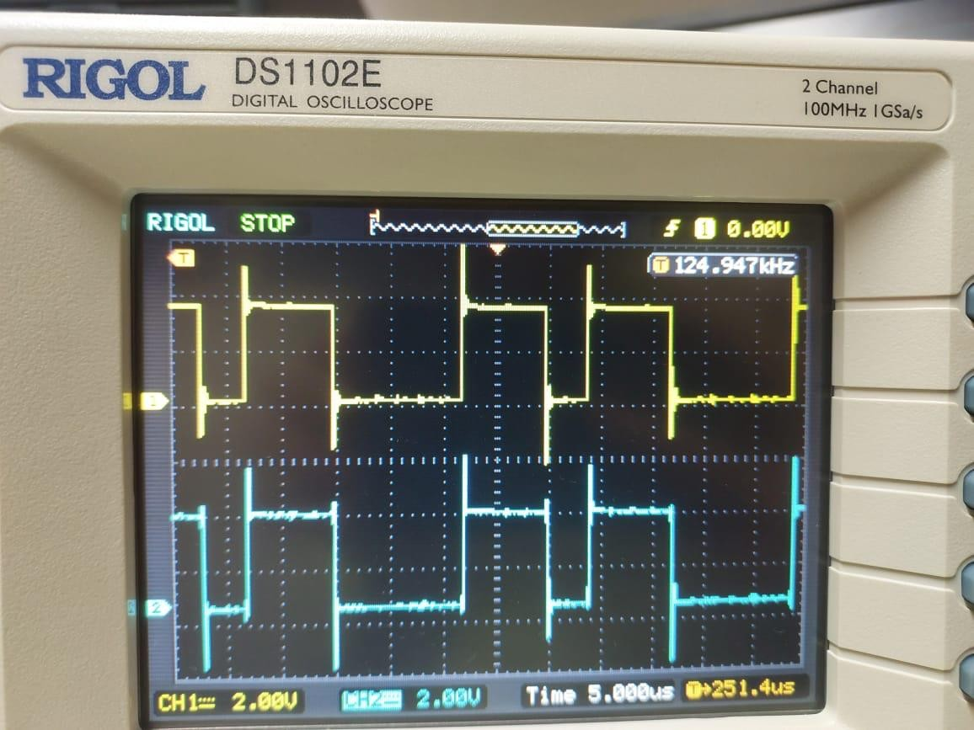

# Question 6.8:

% Parameters

N = 10000; % Number of bits

data = 2*randi([0,1], 1, N) - 1; % Generating random data: +1 or -1

% Channel 1 from 6.7 (assuming a simple FIR filter for this example) h = [0.5, 0.5]; % This is an assumption.

% Variance values

sigma_values = [0, 0.1, 0.2, 0.5, 1.0];

% Loop through sigma values for sigma = sigma_values

% Passing data through channel with AWGN noise received_data = filter(h, 1, data);

noisy_received_data = received_data + sigma * randn(1, N);

% Decision Making: Assuming zero threshold. This might need to change based on your actual channel.

decoded_data = sign(noisy_received_data);

% Calculating error

error = sum(data ~= decoded_data); error_rate = error/N;

fprintf('Error rate for sigma = %f is: %f\n', sigma, error_rate);

|  |  |  |  |  |  |  |  |
| --- | --- | --- | --- | --- | --- | --- | --- |
| end |  | | | | | | |
| Error | rate | for | sigma | = | 0.000000 | is: | 0.496700 |
| Error | rate | for | sigma | = | 0.100000 | is: | 0.249400 |
| Error | rate | for | sigma | = | 0.200000 | is: | 0.249700 |
| Error | rate | for | sigma | = | 0.500000 | is: | 0.255900 |
| Error | rate | for | sigma | = | 1.000000 | is: | 0.321700 |

# Question 6.9:

% For 6.9, it seems we have a different channel h_new = [1, 0.25]; % As described in the problem

% Using the same data and sigma values from 6.8:

for sigma = sigma_values

% Passing data through new channel with AWGN noise received_data_new = filter(h_new, 1, data); noisy_received_data_new = received_data_new + sigma * randn(1, N);

% Decision Making: Assuming zero threshold. This might need to change based on your actual channel.

decoded_data_new = sign(noisy_received_data_new);

% Calculating error for new channel error_new = sum(data ~= decoded_data_new); error_rate_new = error_new/N;

fprintf('Error rate for sigma = %f with new channel is: %f\n', sigma, error_rate_new);

end

|  |  |  |  |  |  |  |  |  |  |  |
| --- | --- | --- | --- | --- | --- | --- | --- | --- | --- | --- |
| Error | rate | for | sigma | = | 0.000000 | with | new | channel | is: | 0.000000 |
| Error | rate | for | sigma | = | 0.100000 | with | new | channel | is: | 0.000000 |
| Error | rate | for | sigma | = | 0.200000 | with | new | channel | is: | 0.000100 |
| Error | rate | for | sigma | = | 0.500000 | with | new | channel | is: | 0.033100 |
| Error | rate | for | sigma | = | 1.000000 | with | new | channel | is: | 0.159600 |